Give the AppCacheID in the console

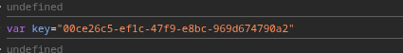

Give the AppCacheUsers Data as ciphertext

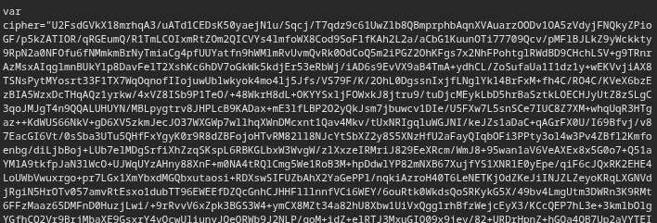

Test whether the value is salted or not

The byte order confirms that the cipher text is openssl salted

Decode the encoded value using the CryptoJS function

The Decoded Value can be seen below

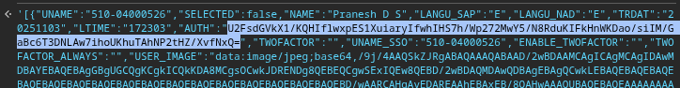

The encrypted text starts with U2FsdGVk - this confirms that OpenSSL/CryptoJS salted format

Successful decryption via CryptoJS.AES.decrypt() proves that AES-CBC with PKCS#7 padding

